1 – Git-HOL Hands-On
Step1: Setting up the machine with Git Configuration -
- To check if Git client is installed properly: Open Git bash shell and executed -
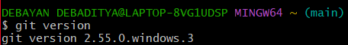
- To configure user level configuration of user ID and email ID execute we execute the following command -
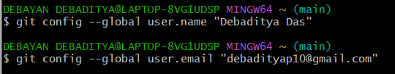
- To check if the configuration is properly set, the following command has been executed –
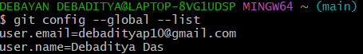
Step 2: Integration of notepad++.exe to Git and making it a default editor
- Checking, if notepad++.exe execute from Git bash
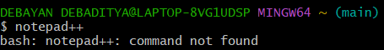
Adding the path of notepad++.exe to the path system variables by clicking on edit, will set up the notepad++.exe with the system’s path.
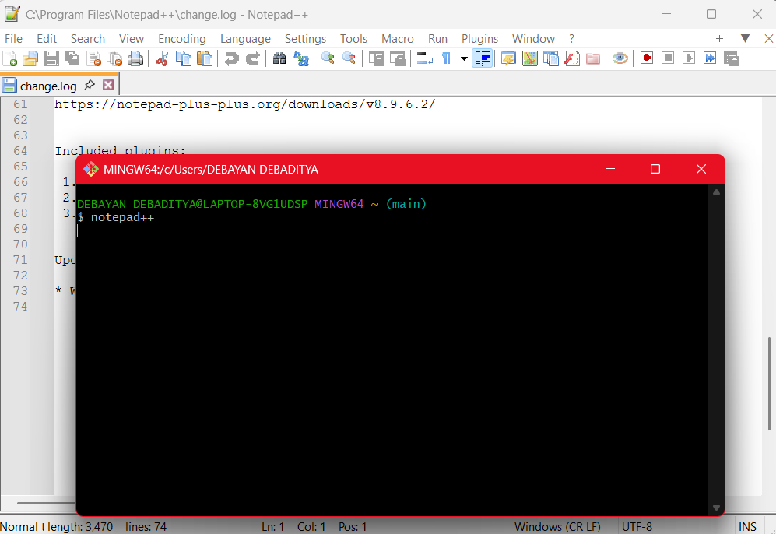
- Then we execute the following code below in the Git bash window, and the following will open the Notepad++.exe instantly.

- To create an alias command for notepad++.exe, execute
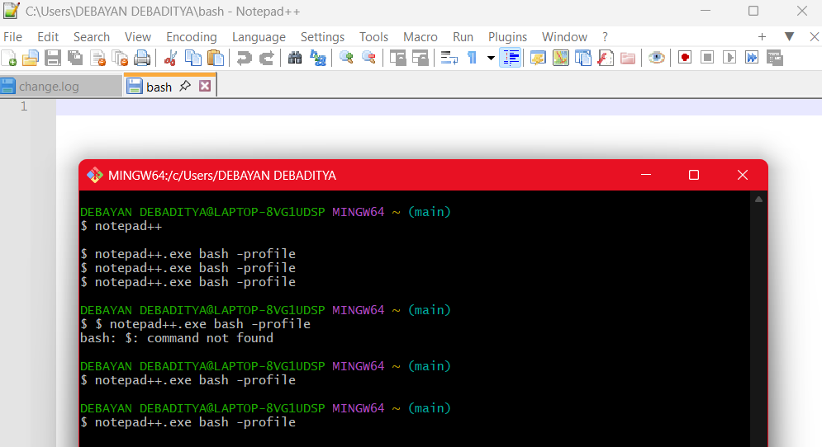
This will open and create a user profile in the notepad++.exe
- To configure the editor, executing this command –
- To verify in notepad++ is the default editor, execute the following command –
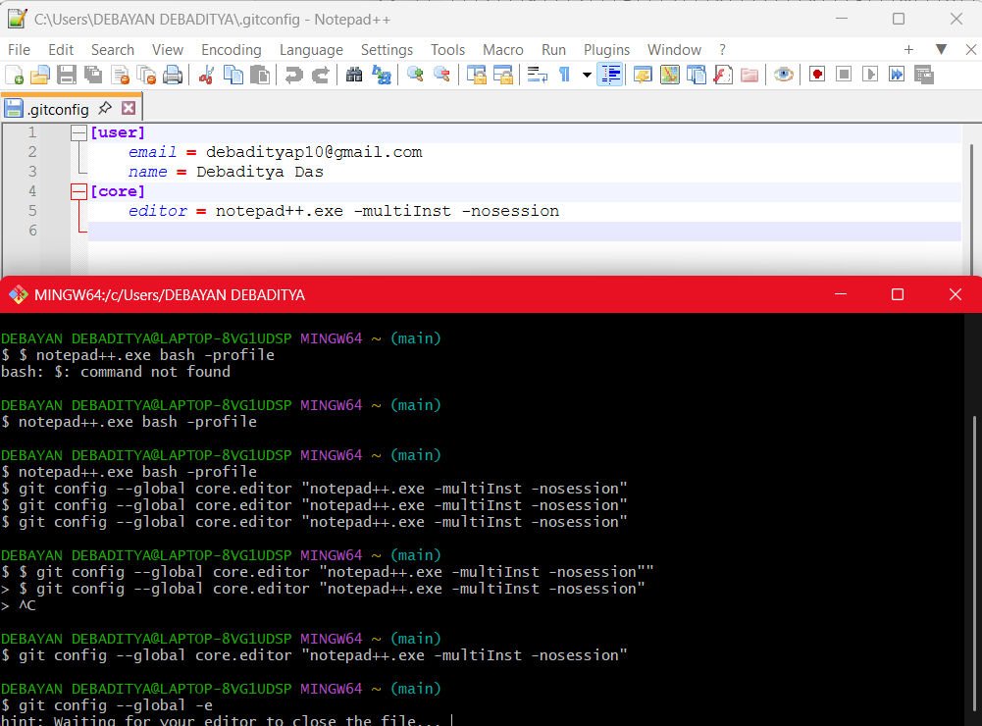
Step 3: Adding a file to source code repository
- Creating “GitDemo” project
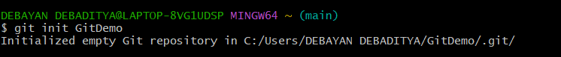
- Initializing the “GitDemo” repository
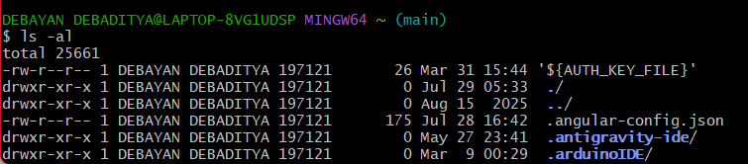
- Creating a file “welcome.txt” and adding content to the file, we execute this command

- To verify the “welcome.txt”
- And to verify the content
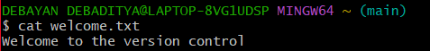
- To check the status
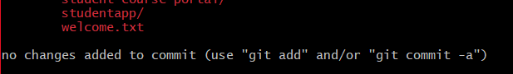
- Tracking the file by Git repository
- To add multi line comment, we are opening the default editor to comment. We execute the following command –
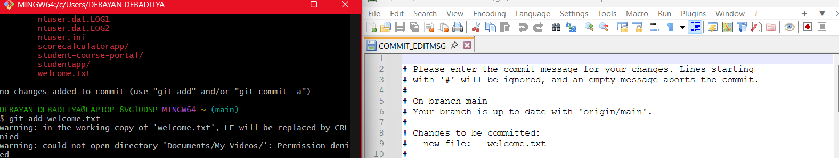
- To check if local and “Working Directory” git repository are same, execute git status

